**B.M.S COLLEGE OF ENGINEERING**

(Autonomous College under VTU)

**Department of Electronics and Communication Engineering**

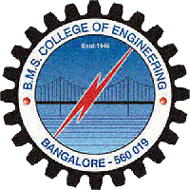

**CERTIFICATE**

This is to certify that the project entitled **“Title of the project ”** is a bonafide work carried out by **Ambika.G.Dath** (USN:1BM08EE005) and **Divya.S** (USN:1BM08EE017) in partial fulfillment for the award of Bachelor of Engineering degree by VTU Belgaum, during the academic year 2011-2012.

Internal Guide **Dr.D .Seshachalam** **Dr.K.Mallikarjuna Babu**

Desg. ECE, BMSCE HOD, ECE, BMSCE Principal, BMSCE

**External Examination:**  **Signature with date:**

1.

2.